IT 1050 – Programming Logic
Take Home Test 1
3 points per problem – 48 points
- Create an infinite while loop. Use a Boolean variable called keepLooping that set to true in the loop’s termination condition. Hint: Use CTRL+C or Debug -> Terminate All to end the program.
int i = 14;
Boolean keepLooping = true;
while (keepLooping) ;
{
if (i <= 13) ;
keepLooping = false;
i++;
Console.WriteLine(i);
}

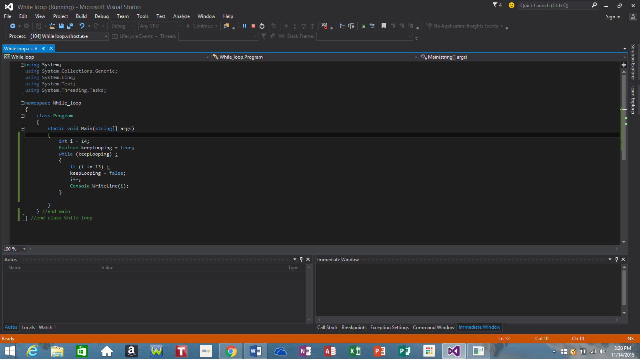

- Write a while loop to prints 1 through6 in square brackets:

[1] [2] [3] [4] [5] [6]

int i = 1, n = 6;
while (i <= n)
{
Console.Write(" [" + i + "] ");
i++;

}

Console.WriteLine();
Console.ReadLine();
}

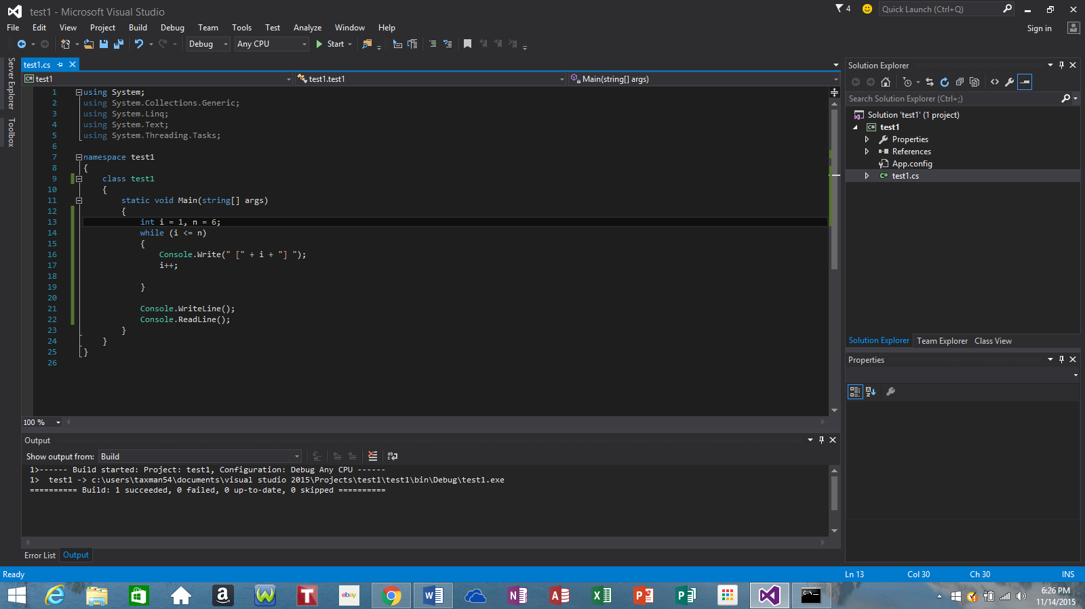

- Write a for loop that computes the sum of first n positive integers. Set the variable n to 12. Print “The sum of all integers from 0-12 is “ + sum
sum = 1 + 2 + 3 + … + n
- Write a for loop that prints 1 through n, separated by commas. Example: for n = 9 print

1, 2, 3, 4, 5, 6, 7, 8, 9

- Write a while loop that prints all even numbers 0 through n, separated by commas. Example: for n = 20 print

0, 2, 4, 6, 8, 10, 12, 14, 16, 18, 20

- Write a while loop that prints all odd numbers 1 through n, separated by commas. Example: for n = 15 print

1, 3, 5, 7, 9, 11, 13, 15

- Given the following code, For n = 7 what is the output?
int n;
int i = 0; // initialize
do {
Console.Write("*");
i++; // update!
} while (i < n); // test!
Console.WriteLine();

How is it different from the while loop?

- Write a sentinel loop that adds all of the numbers input by the end user and outputs the sum. End on a sentinel value input by the user as -1. The prompt should indicate that the user should input -1 to end.

- Write an if-else statement that takes accepts a numeric input for month (example: 1-Jaunary) and outputs the month description. For example, if the user inputs 4, it will output April.

- Re-write problem 9 using a switch statement.

- How do we combine multiple Boolean values? Give 3 primary operators that we use when working with multiple Boolean values.

- Use nested for loops to print a matrix of asterisks with input values numColumns and numRows. Example output for numColumns = 10 and numRow = 3:
**********
**********
**********
- What is an off-by-one error? Create a loop demonstrating off by one – please describe what is happening. Also show the corrected code. Use < in the incorrect version and <= in the correct version of the loop.

- There is a method called Substring that we can use with a string to look at a portion of a string. For example, the following code will print the letter a.
string input = "abcdef";
Console.WriteLine(input.Substring(0, 1));

Given the following input, create a loop that uses the Substring method to count the number of times the letter ‘z’ occurs in a string input by the user.

asdfojiaqweb;ounqwrb;ounwqen;zzzn bnaozonza

Hint: increment the 1st argument in the Substring method call. You must use the Substring method in a loop to get credit!
- Use a for loop to print the following to the console:
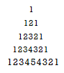
- Input a number from user and displays power of the number. Ask user’s to whether continue or not. If user presses ‘y’ or ‘Y’ then continue and again accept a number. If user presses any other characters or numbers then quit.

